Cirriculum Vitae 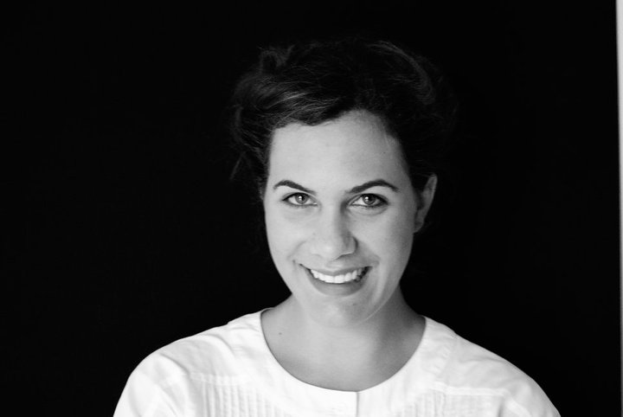

Personal details:
Name and surname: Aglaia – Lito (Alegia) Papageorgiou
Nationality: Hellenic
Address 1: Platonos 10 str., Pallini, Athens Greece
Address2: Blackburn road, Independent Student living
West Hampstead, NW6 1RZ
London, UK
Date/place of birth: 12-01-1991, Athens, Greece
Telephone: 0030-6937728751, 0030-210-6655550
07538827475
e-mail: alegiaki@gmail.com

Education:
- Studies MA Scenography in Royal Central School of Speech and Drama / University of London (2015-2016)
- Video projection mapping course Guildhall School of Music and Drama / London (2016)
- BA Hons in Arts& Design in Interior Architectual design from Vakalo College of Arts- University of Derby (2009-2013)

- Graduated from Ziridis Billingual school (1995-2008)
Foreign languages:
- English FCE Cambridge diploma

- Francais Delf1-DIPLOME D' ETUDES EN LANGUE FRANCAISE 1er degree

Further qualifications:
- Fluency in using design programs such as autocad, 3d studio max, rhinoceros 3d, photoshop, in design, after effects, final cut pro, Isadora core

Work experience:
- During my studies, I worked in the position of secretary at the vascular doctor’s Mr. Antonis Papageorgiou medical office (2009- 2011)
- I was an outdoor colleague, helping with the set & costume preparation,in the theatrical college team of Ziridis school. Leader of the theatrical team was Mrs. Natasha Merkouri (since 2010)
- I worked as an assistant set production manager with the Set designer Mr. Antonis Daglidis, on the following plays:
‘Victory’,National theatre of Greece (2011)
‘To live or not to live’, Katia Dandoulaki theatre (2011)
- I worked as an assistant set production manager with the Set & Costume designer Mr. Manolis Pandelidakis, on the following plays:
‘Theseus and Ariadne’ , Badminton theatre (2013) – set & costume design
‘Demons’, Pallas theatre (2013) – set design
‘Welcome detective Poirot’ , Hellenic motor museum (2013) – set design
‘Trojan war’ , Pallas theatre (2014) – set & costume design
‘Cyrano de Bergerac’, Pallas theatre (2014) – set design
‘Frogs’, National theatre of Greece for Epidaurus festival in Epidaurus ancient theatre (2014) – set design
‘Acharnes’, Athens and Epidaurus Festival in Epidaurus ancient theatre and Herod Atticus Odeon (2015)
- I worked as an assistant costume production manager with the Set& Costume designer Mrs. Eva Nathena, on the following plays:
‘ Quai Ouest’ , National theatre of Greece and Comèdie De Reims (France) (2014)
‘Frogs’ , National theatre of Greece for Epidaurus festival in Epidaurus ancient theatre (2014)
- ‘Deer’ (2015), directed by Konstantinos Rizos, camera : Sioras Deligiannis Giorgos , mask : Aglaia Lito (Alegia) Papageorgiou , performer : Vergina Tsiloni
- ‘Sea’ – A site specific performance dealing with the refugee crisis / audio guided performance within the library (2015), London, Swiss Cottage Library. Directed by Stella Christodoulopoulou, sound edititng: Stella Christodoulopoulou, videos: Konstanti Kamenski. Masks: Aglaia Lito (Alegia) Papageorgiou , photographs of refugees: Chloe Kritharas Devienne, slideshow: Marianthi Grammatikou.
- Set designer for the play: ‘Civil 2’ (2016), National theatre of Greece -1 Experimental stage, Athens Biennale. Directed by Stella Christodoulopoulou.
- Assistant set designer for the worldwide premiere of Edward Bond’s play ‘Dea’ (2016), The Secombre, Sutton theaters, UK.
- Set and Costume designer for the play ‘Hamletmachine’ (2016), directed by Emily Louizou( Collide theatre) , The Ugly duck –the garage, London UK
- Video editing and visual effect for Melina Boukouvala’s video / pole dancing- pole theatre category/ championship, Athens 2016

Further actions:
- During my school years, I picked up from my English teachers to participate at M.U.N. (Hague Model United Nations), located in Hague (Holland) as an ambassandor of Barbados (2006)

- I attended the Laboratory of set & costume design for ancient greek drama, with Mrs. Anna Machairianaki and Christine Papageorgiou at Michael Kakogiannis foundation (2012)

- I joined a series of lectures in the aspect of Interior Design at Vakalo college of Arts conference room (2010-2013)
- I attended Mr. Michael Wolff’s (iconic designer) lecture at Onassis cultural center (2014)
- I attended butoh dance workshop / London (2016)
- I attended 3d print workshop / London (2016)
- I attended pihhole photography workshop / London (2016)
- I attended Millinery workshop / London (2016)
- I attended hacking and sensors workshop / London (2016)

Hobbies & Interests:
In my spare time my main interests and hobbies lie in the arts. Film, photography, museums, art exhibitions, music and reading take up most of my time. I enjoy filming and use this data in making video (video art) as well as creating mixed media masks and small sculptures. I love travelling and have extensively travelled throughout Europe. Apart from contemporary and jazz dance and yoga I play the guitar.

References:
Mr. Antonis Papageorgiou (Leader of tha vascular unit in Ν.Ν.Α hospital)
Mr. Antonis Dgklidis(Set designer)
Mrs . Natasha Merkouri (Literature teacher at Ziridis Bilingual school)
Mr. Manolis Pandelidakis (Set & Costume designer)
Mrs. Eva Nathena (Set & Costume designer)
Mr. Sakis Birbilis (Stage lighting designer)

Vakalo college of Arts from the following professors:
Mr. Padelis Tsavalos ( Art historian – Dean)
Mr. Andrea Sarantopoulo ( Set & Costume designer)
Mr. Manolis Iliakis (Architect)
Mr. Harry Papaioannou (Architect)

