ARTIST SUVAM
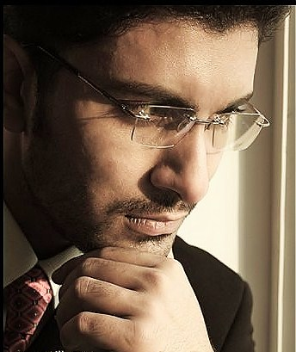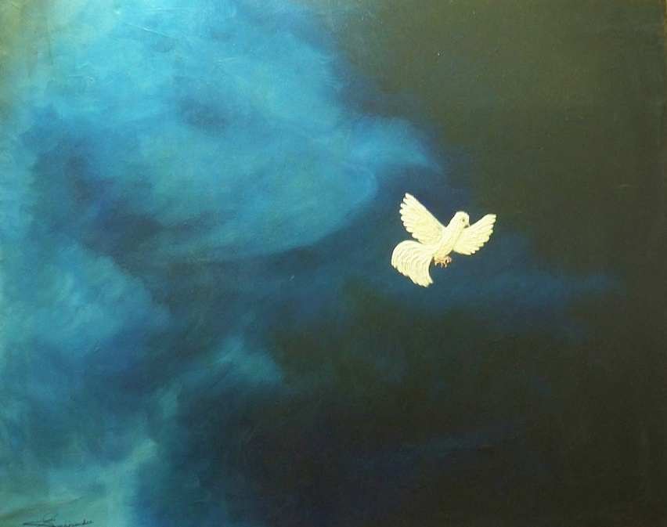
ARTIST STATEMENT: Imagination has no barrier. It is stronger than anything known to man, faster than the speed of light, deeper than the ocean of thoughts. It is the seed for the basic intellect of creativity & innovation. The displayed works are just some mere examples of reinvention of creative bliss. Every work has a deep thought & meaning supporting its visual description.
Artist Inspiration: Talents are not taught, they are innate gifts of the divine. Suvam has been blessed with such a gift. Always artistically inclined, he began drawing and sketching at a very young age. His unique perspective brings a tone and life to his art that is distinctive. Though educated in the sciences, Suvam prefers a life that centers around his passion that is painting. The skill depicted in his work speaks volumes about his intense creativity and artistic ingenuity. His creative vision and concepts are – widely admired. His work is complex, and multi-layered, compelling his audience to seek the profound messages buried within. He enjoys studying other artists, and draws his inspiration from them. He believes knowledge is eternal, and strives to achieve excellence in everything he does.
BIO: I am a self taught artist. Painting has always been my passion as far back as I can remember. Several challenging situations in life taught me the kinds of lessons that will guide me for the rest of my days. Perhaps this is why most of my work is based on pain and suffering. I believe in the eternal pursuit of knowledge, and I enjoy learning from others. Often I make discoveries in the process of working on a piece, I cherish these precious nuggets of wisdom. I am not bound to any singular style or technique, I sometimes complete an entire painting without a brush, blending my own colors into unique hues. I believe that creativity doesn’t lie in the instruments we use, rather it’s the mind that is the ultimate seed of creativity.
FULL NAME: Suvam MUKHERJEE
DATE OF BIRTH: 1st March 1984
ADDRESS: 1/1, Satyen Roy Branch Road, Behala, Kolkata-700034
CONTACT: +919830338662 (mobile)
033 2445 0162 (residence)
http://www.artslant.com/ew/artists/show/64163-suvam-mukherjee
The above link is of the online gallery where four of my global showcased winner works can be found.

