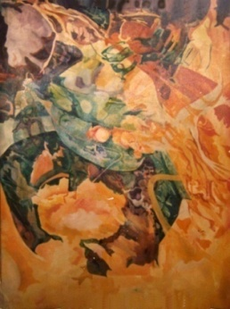  
 **Queen of Death 1971**

*Rick Hoffman has been painting since 1966.* In 1969 attended the Tyler School of Art studying with **David Pease**, **Richard Kramer**, **Stephen Green,** **Rudy Staffel,** and **Richard Callner.** While at Tyler he began to work in the Psychedelic/Surrealistic Style painting in acrylic and oil on canvas

But by the summer of 1972 his work was moving to a more "expressionistic and cryptic figurative style". These are typically painted on wood panels in oil. Over time they evolved to cut out low relief painted sculptural constructions which included "found objects". The first of these was ***"The Cross Eyed Man Singing"*** which won a major Gallery Award in 1972 in Philadelphia. This encouraged the artist to work in this style for the next 10 years. His "self conscious awareness" of the window like limitation of the stretched canvas was met head on with frequent paintings within paintings, mirrors, landscapes in windows and occasional carved cut out figures glued on to the surfaces.

In 1980 he entered NYU pursuing a master’s degree. There the work moved from the narrative low relief cut wooden panels to paintings on paper, typically 30"x22" arches sheets and using commercial paint sprayers to propel acrylic paints mixed with textured materials. The subject matter came extensively from his photographs - as images dissected and projected. Layers of reality superimpose and mixed imagery replaced the straight forward narratives of the earlier period. ***"Ambient Deer"*** is the major piece of this era of Rick’s work measuring 12 feet by 8 feet painted in acrylic and mixed media.

Since the early 1990s Rick has continued to revisit the thousands of photographs he has taken over the years. The painted Images he makes typically come from photographic assemblages as subject matter. These are frequently of animals and female forms in unimaginable places creating ephemeral dreamscapes. Although on occasion ideas for unique series of works emerge. In 1992 he started making small intimate multimedia collages. These continue to surface through 2010. Another series are “*Painted Newspapers”. Quite literarily that!*

*In 2005 through 2008 he worked primarily in PhotoShop, with an emphasis on his unique surreal reality. In addition the first short films were made which were an attempt to enhance the narrative beyond the “original painted images”. In 2008 he presented a retrospective show at Fairleigh Dickinson University featuring over 100 pieces of his art.*

*In the summer of 1971 Rick created one small multimedia piece for 26 days in July and August. Each i*s *on an 8"x10" piece of construction paper. The media is pastel, ink, ebony pencil, dyes, metallic pens, acrylic and gauche. Accomplishing this disciplined a body of more or less traditional painted work was very rewarding* ***....The exercise was repeated again in 2010 - forty years later.*** *This time they are 9"x12"on Yupo or Bristol Paper. By August 1st* ***63*** *small paintings were completed.*

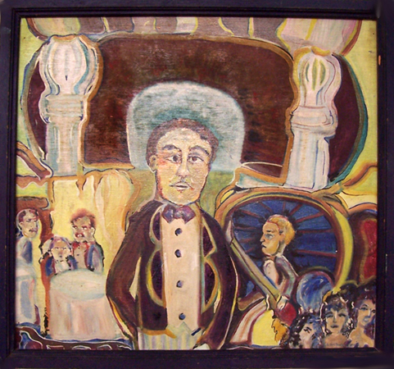

**Cross Eyed Man Singing 1972**

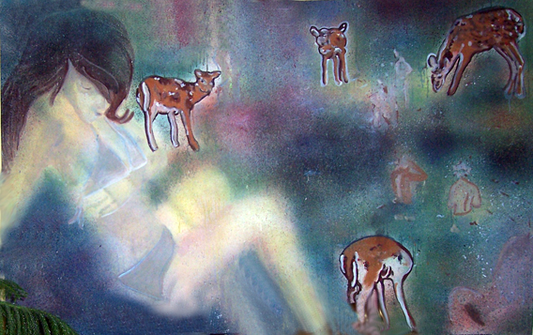

***Ambient Deer 1982***

***7.17.10 2010***

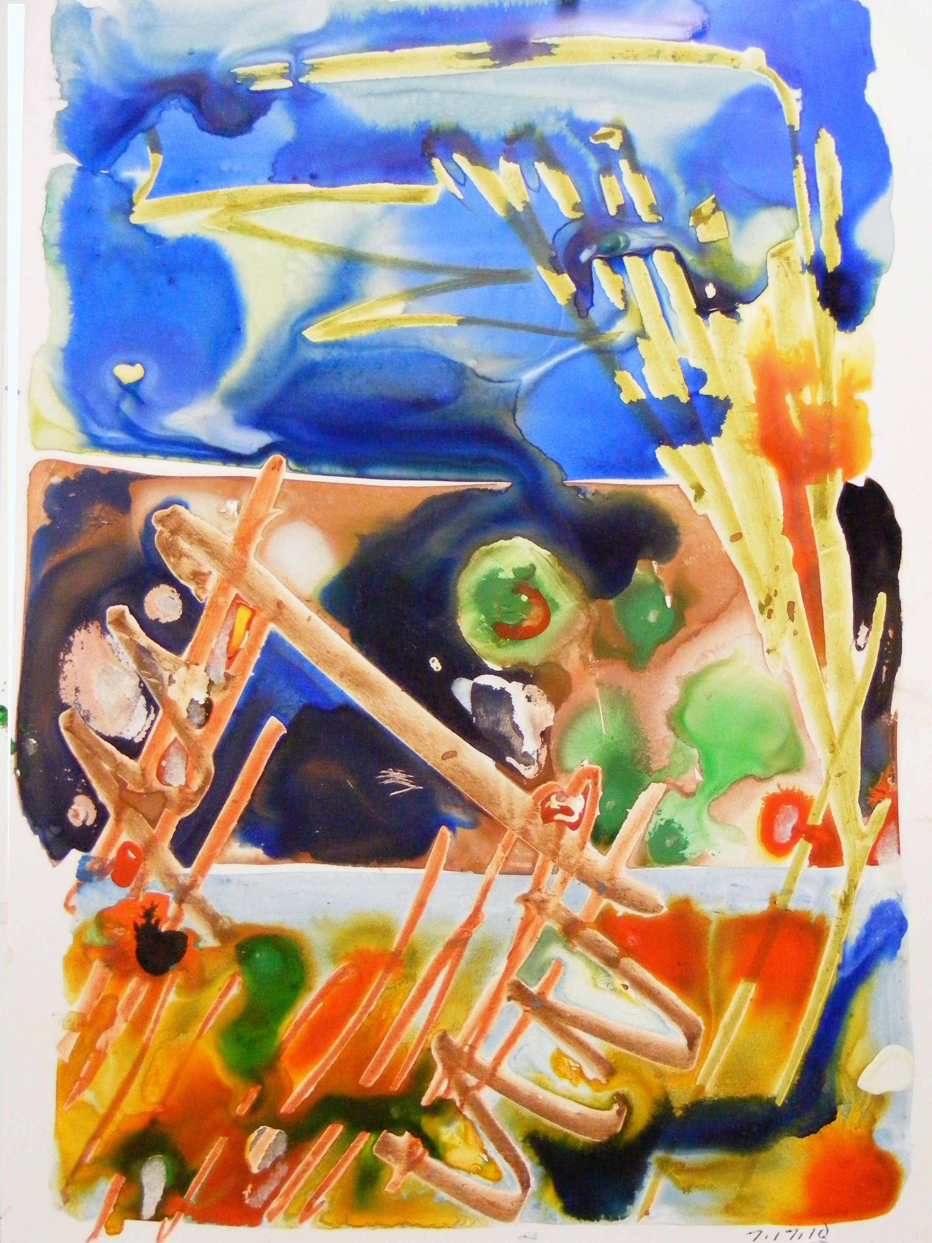

7.17.10

***Leafy Glaze 2009***

