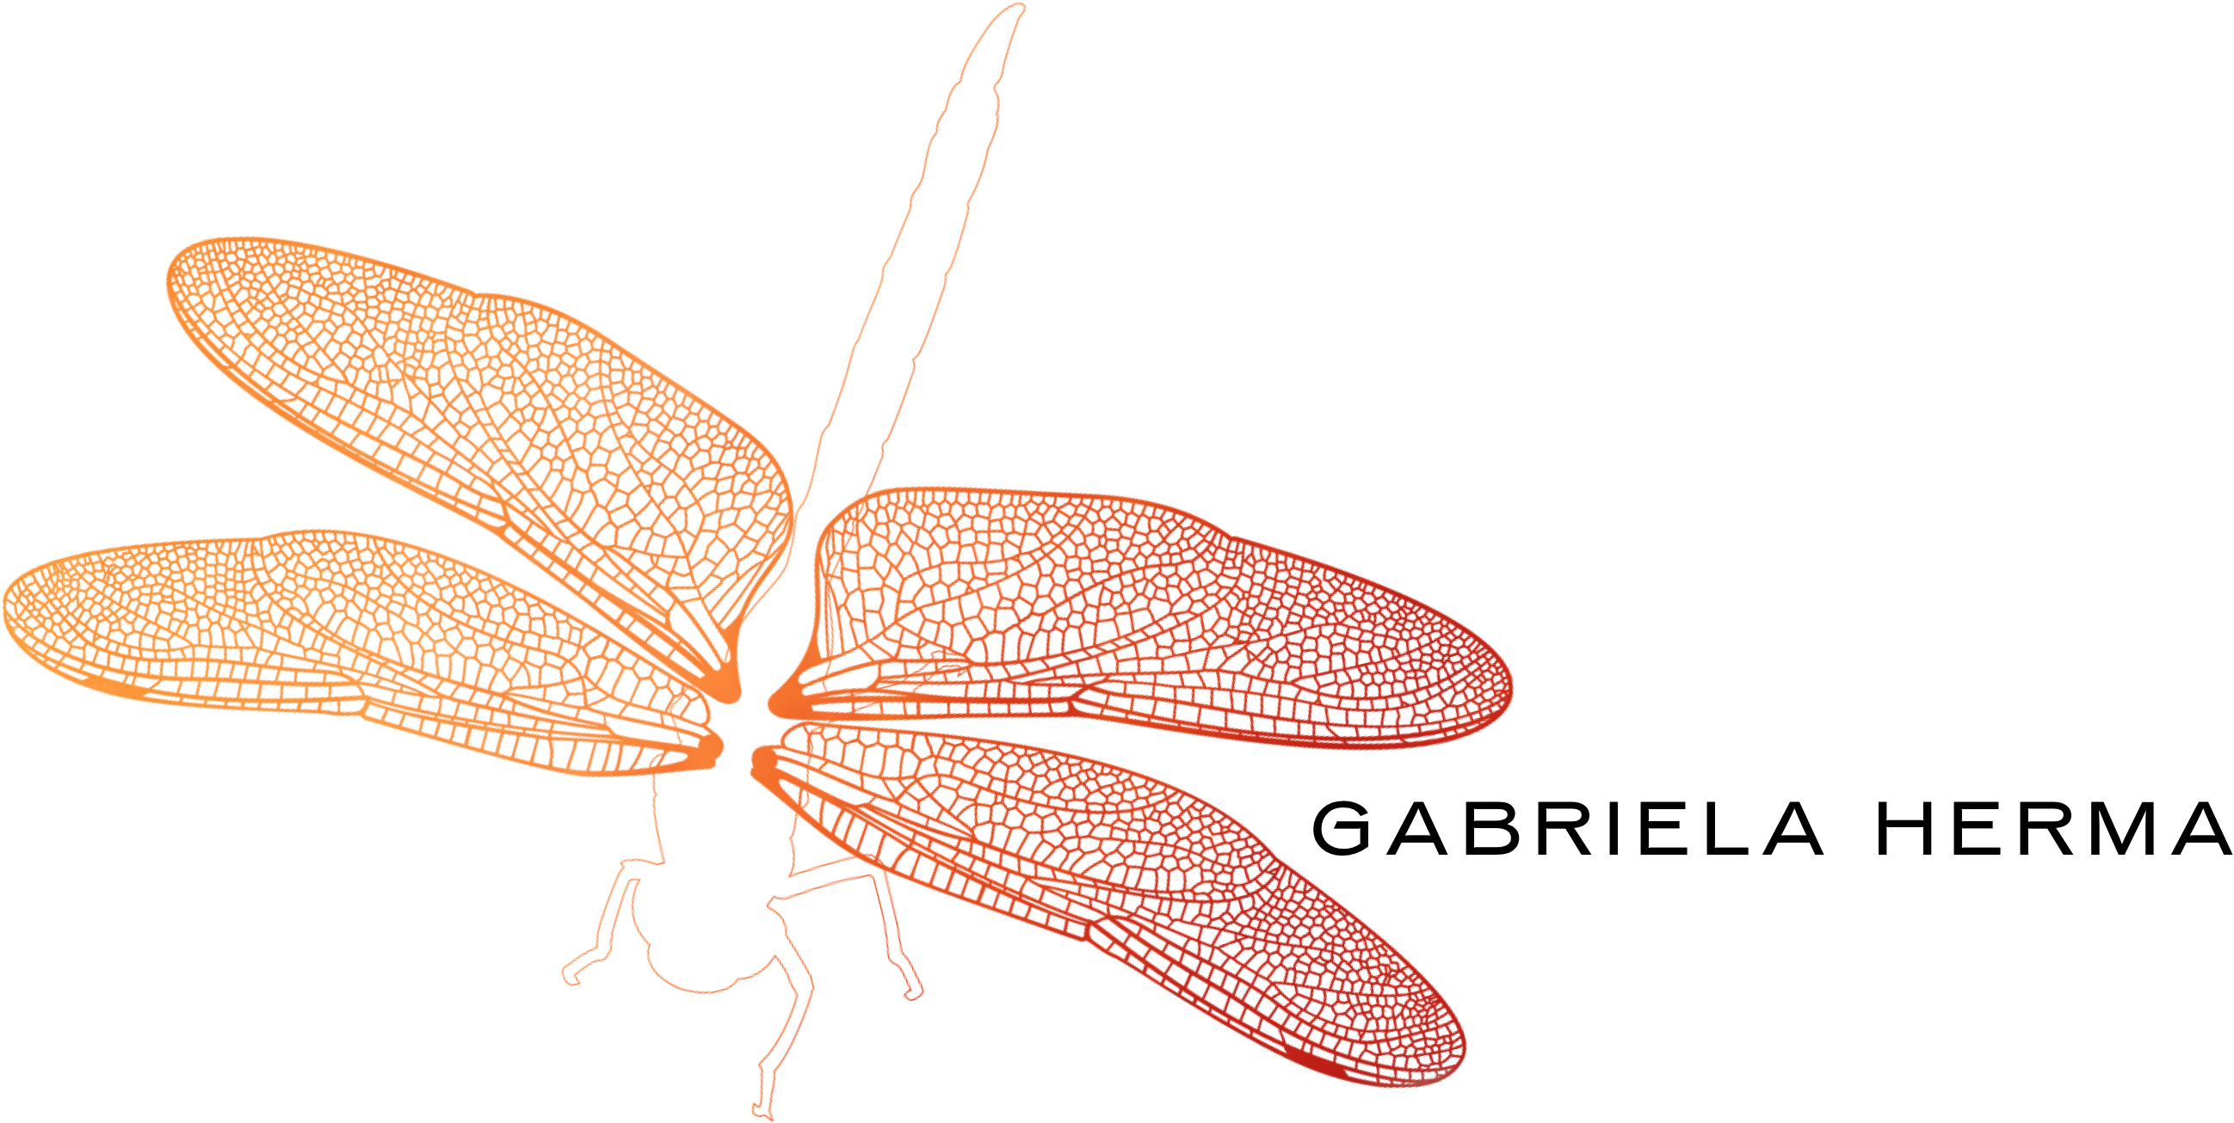

GABRIELA HERMA

Gabriela Herma is a Polish Fine Art Photographer, based in London and represented by Le Dame Art Gallery. Her work is inspired by her surroundings and led by her initial emotional response. Each photograph conceals a deeper meaning and emotion that the artist invites her viewers to explore. Encouraging us to see beyond what can be seen.

Herma's photographs are finely printed onto metal and later supervened with resin and mixed materials such as Swarovski, broken mirrors and sparkle dust. Her photographs freeze moments of emotion which are brought to life by the process of layering them with resin and reflective elements, emphasizing the reality and tangibility of natural details and injecting a vitality that invites the spectator to step into the scene and experience first hand the moment Herma captured.

One of Herma’s most significant works is Giulia, 2015. Guilia is the depiction of a red dragonfly that Herma had the pleasure of encountering in Marbella, Spain, in August 2015. The dragonfly almost flirted with Gabriela's artistic senses as if she was silently but purposefully requesting to be captured her by her camera. The dragonfly is a symbol of transformation that encourages us to seek self-realisation and uncover the deeper meaning of life. Guilia is a representation of Herma’s own internal growth and ability to see beyond the surface meaning of her subjects, a redline through her work.

Past events:

- Italian Vanity Art Fair, The Gallery of Light Ductat – Mall of Emirates, Dubai, 4th-10th May 2017.

- Venice Biennale, Accorsi Arte Gallery, San Stae, Palazzo Priuli Bon, Venice, 14th May – 4th June 2017.

