CV/RESUME

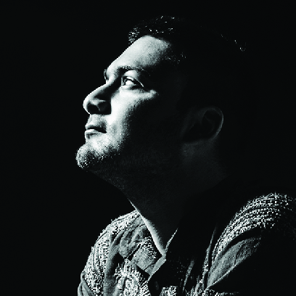
Personal Details
Name: Taha Ahmad
Date of Birth: 20/11/1994
Sex: Male
Marital Status: Unmarried
Citizenship: Indian Email: taha.ofmart@gmail.com

Qualifications Summary
- BFA (Applied Arts) from Jamia Millia Islamia University,New Delhi, India-110025
- Currently pursuing MFA (Applied Arts) from Jamia Millia Islamia University,New Delhi, India-110025
Work Experience
- WWF (World Wide Fund for Nature) over the DST Core Project.
- Mentored by Delhi based photographer Sandeep Biswas.
- Guided by Turkey based photographer Tahir Un, AFP photographer Joseph Eid and Delhi based photographer Sharbendu De.
Achievements
- Recipient of the Neel Dongre Grant/Award for Excellence in Photography 2016 organized by the India Photo Archive Foundation
- Selected for the India Photo Festival (IPF) 2017 in Hyderabad.
- Received Third prize in the National Graffiti Competition ' Delhi Wall Book' organised by Select City Walk, Delhi, India
- Won the second prize in the International Everyman Photo Contest(Landscape and Nature) 2015 (New York)
- Selected among the 30 photographers from India, in the National Travel Photo Exhibition organized by Girl Count in collaboration with Bet Bachao Beti Padhao, UNFPA India, UN Women India, National Foundation for India 2016
- Received the Nicephoto Photographer of the Year 2016-17
Publications and Exhibitions
- Work has been exhibited at the MF Husain Art Gallery, India Habitat Centre, Jaipur Art Summit, IIT Delhi, and India International Centre
- Works has been published in the Better Photography Magazine, Platform Magazine, Amateur Photographer UK (Best 10 photos from Sony World Photography Awards), Fountain Ink, Times of India, Asian Age, Art Arcade, The Sunday Guardian, Navoday Times, Deccan Chronicle, Rashtriya Sahara, The Quint, Edge of Humanity, IZ Magazine, Dhodho Magazine, Invisible Photographer Asia, etc.
Skills
- Comfortable with various software's like Adobe Photoshop, Adobe Illustrator, Lightroom
- Familiar with the techniques of the light sources and the Digital Camera operations
- Efficient in the task of Post Processing Photographs creatively

