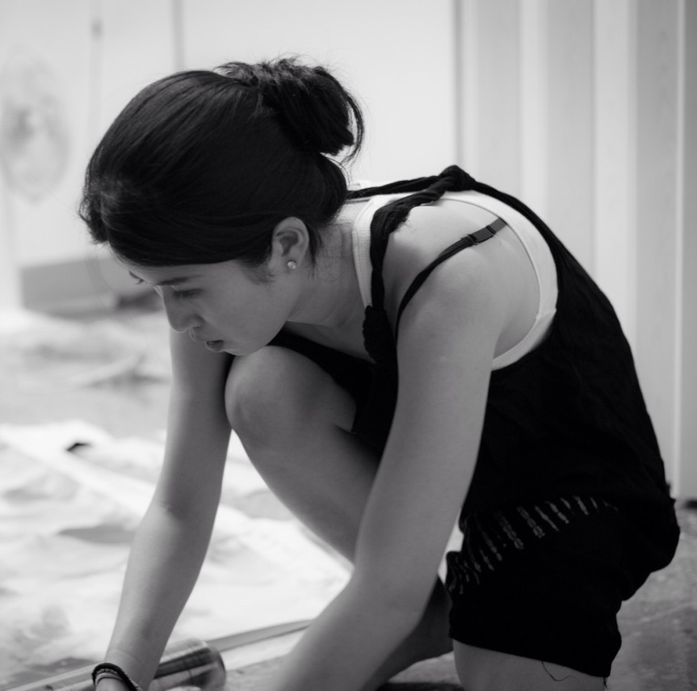
Peihang Huang
Born in Taipei, Taiwan, 1984
EDUCATION
Chelsea College of Arts, MA Fine Art National Taiwan Normal University, Department of Fine Arts MFA
SOLO EXHIBITIONS
2017(Up coming) Start Art Fair, Saatchi Gallery, London, Uk
2016 [UN/REAL] Grace Belgravia with Mehtabell Projects, London, UK
2015 Apocalypes, Aspace for Art collaboration, Sake no Hana, London, UK 2011 Made in Berlin:the Encounter,Tam Tam Art ,Berlin, Germany
2009 Fleshly Fairy Tale AKI Gallery, Taipei, Taiwan
Selected GROUP EXHIBITIONS
2016 The Future and Potential of TAIWANESE & Japanese Contemporary Painting, Museum of Tokyo University of Arts, Tokyo, Japan
2016 Future Island-Start Art Fair Project, Saatchi Gallery, London, UK
2016 Fast Foward, Rewind -Chelsea Alumni Show, Punctum Gallery, London, UK
2016 Affordable Art Fair Battersea, Battersea Park, London, UK
2016 Artists of the Future, Degree Arts, London, UK
2016 Up26 Auction, Polymer Studios, Taipei, Taiwan
2015 Apocalypse, A space for Art collaboration, Sake no Hana, London, UK
2015 Indescribable Figure-New Figurative Painting in Taiwan,
Jing-Lu Art, Taipei, Taiwan
2015 MA Fine Art Degree show, Chelsea College of Art, London 2015 Concrete Compendium CG11 , London 2015 compoSITE Chelsea MA Fine Art interim show, Triangle space, London 2015 Speed and Agility with Lewis PR, The House Mill,London 2014 Tangent, Chelsea MA Fine Art Mid interim show. Triangle space, London

