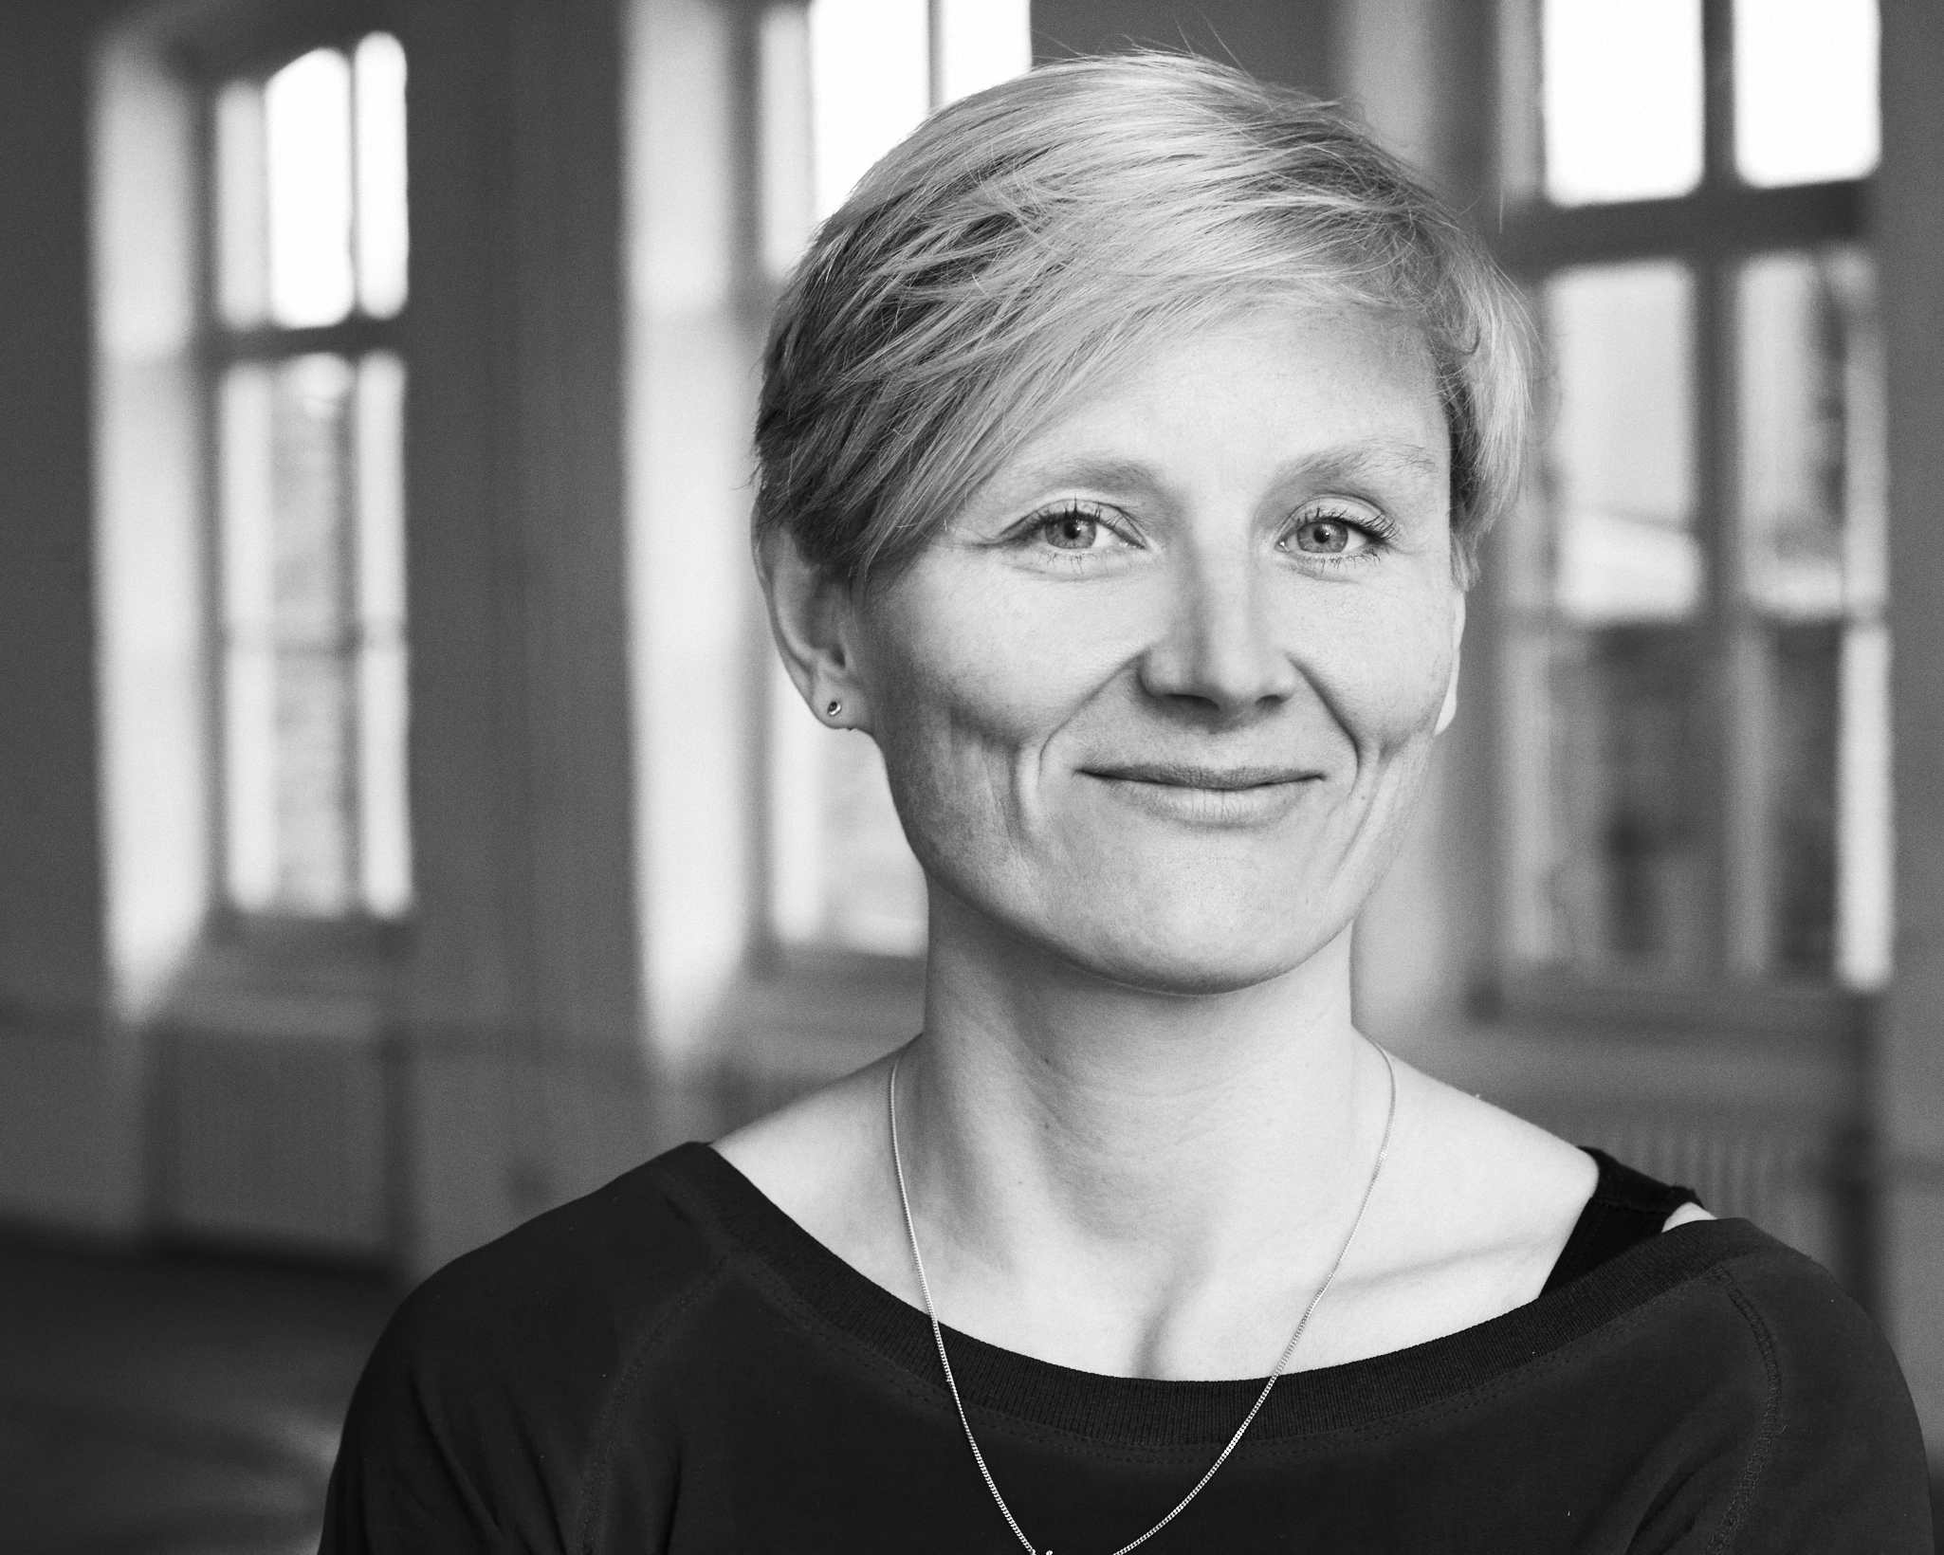
Ellen Blumenstein

* 1976 in Kassel
Lives in Berlin

Ellen Blumenstein holds an M.A. in literature, musicology and media studies and is the founder of Salon Populaire (2010-12), a discursive event space on the threshold of institutional representation and artistic production in Berlin. She directs the program of KW Institute for Contemporary Art, one of the world’s renowned institutions of its kind, since 2012, and has been working in the field of contemporary art for more than 15 years on an international scale.
As a specialist for the conditions of development in today’s cultural production, she regularly advises foundations and political bodies and teaches at international Art Academies in Switzerland, the Netherlands and Germany. She actively engages in the improvement of education for young artists and curators, participates in juries and lectures on her work internationally.

Education
1995–98
German Studies, Musicology, Journalism, Hamburg University, B.A..

1998–2000
Modern German Literature (Focus: Theater/Media), Musicology, Media Studies, Free University of Berlin, M.A..

1997–2001
Internship and assistance at the press office of documenta X, Kassel.
Project management and associate curator at KW Institute for Contemporary Art, Berlin.
Project management at MoMA PS1, New York, and Museum Folkwang, Essen.

Languages
English, Spanish (fluently), French, Portuguese (good).

Exhibitions

2016
Secret Surface (with Catherine Wood/Tate Modern, London), KW, Berlin.
Channa Horwitz, Raven Row, London.
Fire and Forget 2 (with Daniel Tyradellis), Museum for Applied Arts, Frankfurt am Main.

2015
Michael Müller: Who’s Speaking?, KW, Berlin.
Gusmao/ Paiva: Papagaio, KW, with Hangar Bicocca/ Milano, Camden Artcenter, London.
Welcome to the Jungle, KW, with New National Gallery, BG, Kunsthalle DB, Berlin.
Fire and Forget. On Violence (with Daniel Tyradellis), KW, Berlin.
Channa Horwitz: Counting in Eight, Moving by Color, KW, Berlin.
Elín Hansdóttir: Suspension of Disbelief, KW, Berlin.
Renzo Martens: The Matter of Critique, KW, Berlin.

2014
Real Emotions. Thinking in Film (with Franz Rodenkirchen, Daniel Tyradellis), KW, Berlin.
Lizzy Fitch/Ryan Trecartin: Site Visit (with Klaus Biesenbach), KW, Berlin.
Kate Cooper: Rigged, Schering Art Prize, KW, Berlin.

2013
Relaunch, KW, Berlin.
Kader Attia. Repair. 5 Acts, KW, Berlin.
The Living Archive, with Arsenal—Institute for Film and Video Art, Berlin.
Painting Forever: Stretcher Frame, KW, with New National Gallery, BG, Kunsthalle DB, Berlin.
Formations of Bodies, KW, Berlin.

2009–11
Ólafur Ólafsson/Libia Castro: Under Deconstruction, Icelandic Pavilion, Venice Biennial, 2011.
Anthem for the Peoples’ Tomorrow, Piet Zwart Institute, Rotterdam, 2011.
End of Year Exhibition, Academy of Fine Arts, Nuremberg, 2010.
The Berlin Wall —Reflections on History, Museu do Chiado, Lisbon, 2009.
The Pain Game, Nosbaum & Reding, Luxembourg, 2009.
The Human Stain, CGAC, Santiago de Compostela, 2009.

2004–8
Agulhas Negras at CCSP, São Paulo, 2008.
Art as Research, Villa Elisabeth, Berlin, parallel to SLSA Conference Figurations of Knowledge at ZFL Berlin, organized by Y (Institute for Trans-disciplinarity), HFK, Berne, 2007 (co-curator).
Male Fantasies I+II, Chung King Project, Los Angeles/COMA, Berlin, 2007–08.
Between Two Deaths (with Felix Ensslin), ZKM, Karlsruhe, 2007.
Reflecting Terror: The RAF-Exhibition (with Klaus Biesenbach, Felix Ensslin), KW, Berlin/New Gallery, Graz, 2005.
The 10 Commandments (co-curator), German Hygiene-Museum, Dresden, 2004.
Projects

The Bet: An Examination on Doubt, Contingency and Meaning in Economy and Society, KW, Foreign Affairs Festival/Berliner Festspiele, Berlin (performance weekend), 2013.
Steal Me!, Talk Show with Dora García, dOCUMENTA(13), Kassel, (cooperation), 2012.
Paris-Berlin, The Office/Palais de Tokyo, Paris and Berlin (performance installation), 2012.
Strike Opera with Ulf Aminde, Judith Raum, Anders Smebye, University Orchestra Graz, as part of the Truth is Concrete Congress, Steirischer Herbst, Graz (stage production), 2012.
Salon Populaire, Berlin (venue for public programs), 2010–12.
The T-i-t-l-e-e-r (with Daniel Tyradellis), artissima 18, Turin (one-day Podium Discussion), 2011.
Perform a Lecture!, The Office, Berlin (series of performance lectures), 2010.
Blow up my Town, THE KNOT/Tempelhof Air Field, Berlin (film program), 2010.
The Office, with K. Fichtner, M. Lopez, K. Meyer, Berlin (curatorial collective), 2009–11.
The Man Who Wasn’t There, The Barber Shop, Lisbon (video installation), 2009.
Agulhas Negras – A Summer Session. About the Necessity to Fiscuss the Social Functions of Contemporary Art, Campos de Jordão (summer academy), 2008.
Home Alone: Some Proposals on How to Deal with it, UNP, Berlin (film program), 2007.
Summer Films with Katharina Fichtner, KW, Berlin (film program), 2006.
Galerie carlier | gebauer, Berlin (curator), 2006.

Networks
projekt bauhaus, national discussion- and event platform, 2015–2019.
CORPUS, international performance network, with Tate Modern, London; CAC, Vilnius; MAM, Leuven; If I can’t dance..., Amsterdam; Bulegoa, Bilbao, 2014–2017.

Bibliography

Editorship and Monographs
Channa Horwitz. Monograph (Ed.), Spector Books, Leipzig, 2016.
Michael Müller: Whos’s Speaking? (Cat., Ed.), Hatje Cantz Verlag, Ostfildern-Ruit, 2016.
Kate Cooper: Rigged (Cat., Ed.), Sternberg Press, Berlin, 2015.
Image of a City—A Reader (Co-Ed.), Verbrecher Verlag, Berlin, 2015.
Friendly Fire and Forget (Ed., with Daniel Tyradellis), Matthes & Seitz Berlin, 2015.
Lizzie Fitch, Ryan Trecartin: Site Visit (Cat., Ed.), Koenig Books, London, 2015.
KW Pocket 4: The Retraction of Things, (Ed.), Spector Books, Leipzig, 2015.
Kader Attia: Transformations (Cat., Ed.), Spector Books, Leipzig, 2014.
KW Pocket 3: Ilit Azoulay, Shifting Degrees of Uncertainty, (Ed.), Spector Books, Leipzig, 2014.
KW Pocket 2: Merlin James, (Ed.), Spector Books, Leipzig, 2014.
KW Pocket 1: Nedko Solakov, Markierung, (Ed.), Spector Books, Leipzig, 2014.
Painting Forever—Stretcher Frame (Cat., Ed.), Kettler Verlag, Dortmund, 2013.
Anthem for the Peoples’ Tomorrow (Ed.), Spector Books, Leipzig, 2011.
Under Deconstruction. Libia Castro/Ólafur Ólafsson (Ed.), Sternberg Press, Berlin, 2011.
Perform a Lecture! (Ed.), argobooks, Berlin, 2011.
The World According To (Co-Ed.), mit Iñaki Bonillas, Olaf Nicolai, Dora García, Gert Jan Kocken, argobooks, Berlin, 2009–12.
On Placelessness..., Marion Ermer Art Prize (Cat., Ed.), argobooks, Berlin, 2009.
The Human Stain (Cat., Ed.), CGAC, Santiago de Compostela, 2009.
Male Fantasies (Cat., Ed.), argobooks, Berlin, 2008.
Between Two Deaths (Cat., Ed., with Felix Ensslin), Hatje Cantz Verlag, Ostfildern-Ruit, 2007.
KW Magazine: Media Realities (Ed., with Anselm Franke), Abbas Kiarostami, Warten, Piotr Uklanski (Ed.), 2001–04.

Articles, Essays and Interviews

2015
Becoming Real, in: Insomnia (Cat.), Bonniers Konsthall, Stockholm.
Change of Horizon. Manipulation Strategies to Redirect Sight in the Work of Julius von Bismarck, in: Animals are Dumb and Plants are even Dumber (Cat.), Kerber Verlag, Bielefeld.
A Conversation with Schorsch Kamerun, in: Friendly Fire and Forget (Ed., with Daniel Tyradellis), Matthes & Seitz Berlin, pp. 6–20.
Society’s Idiots, in: Fitch/Trecartin: Site Visit (Cat., Ed.), Koenig Books London, pp. 42–47.
Interview on the State of Affairs in the Art Scene of Berlin, tagesschau (news program), 15.09.
Kompressor, Interview, Deutschlandradio Kultur, 29.05.
Ellen Blumenstein. My Art Cosmos, Emotion, 02/15 (interview).
Experts Recommend, Art Investor, 01/15.

2013–14
Randonnée: Objects and Quasi-Objects, in: Kader Attia: Transformations (Cat., Ed.), Spector Books, Leipzig, 2014, pp. 27–36, 173–182 (engl./ger.).
An Almost Mythical Berlin Story. The Berlin Curator Ellen Blumenstein, Deutschlandradio Kultur, 29.05.2014 (portrait).
Director’s Cut, Harper’s Bazaar, 02/14 (portrait).
General Framework. 20 Sentences on the Stretcher Frame, in: Painting Forever (Cat., Ed.), Kettler Verlag, Dortmund, 2013, pp. 2–4.
Expansion and (Self-)Exposure. Ellen Blumenstein at KW, vonhundert, 20.12. 2013 (portrait).
A Curator Looking for Debate, Kunstjahr 13/13 (portrait).
Non-Profit Organisations, Frieze/de , 15.10. 2013 (interview).
Curator’s Key—Ellen Blumenstein, Spike Art Quarterly, 23.09. 2013 (interview).
Berlin Art Week, tagesschau (news program), 17.09. 2013 (interview).
Art Chronika (RU),14.08. 2013 (interview).
Ellen Blumenstein in Conversation on her New Vision, Weapons and the Public, Vogue, 19.06. 2013 (interview).
Fresh Air at KW, ExBerliner, 06/13 (portrait).
KW's New Chief Curator on Reinventing the Berlin Institution, Blouin Artinfo vom 16.05. 2013 (interview).
Clean Sweep at Auguststraße 69, Die Welt, 15.5. 2013 (portrait).
Ellen Blumenstein, Interview Magazine, 30.04. 2013 (interview).
Fazit, Deutschlandradio Kultur, 26.04. 2013 (studio conversation).
The Avatar Lightens my Work Load, art online, 26.04. (interview).
Window on the World, tagesspiegel, 25.4. 20913 (portrait).
Fantasy, Research, Passion, Berliner Zeitung, 25.04. 2013 (portrait).
Insisting on an Area of Freedom, Zitty, 04/13 (interview).
There is this Dangerous Tendency Towards Event Culture, TIP, 04/13 (interview).
Ellen Blumenstein has Cleaned Up, Informationsdienst Kunst, 02.05. 2013 (portrait).
Waiting and Planning. Ellen Blumenstein, New Chief Curator of KunstWerke, Kunstzeitung 01/13 (portrait).

2012
The Unsettling Installations of Rabih Mroué, in: frieze, no. 151, pp. 108–9.
Politics of the Medium, in: Mad Marginal #3, Klau Mich, Koenig Books, London, pp. 40–49.
The T-i-t-l-e-e-r, in: A Classroom, Passenger Books, Zurich, pp. 73–78.
Ellen Blumenstein. Director of Kunst-Werke Berlin, FAZ, 20.07. (portrait).
The Intruder. Ellen Blumenstein is the New Chief Curator at KW, Zitty, 26.07. (portrait).
Six Questions to Ellen Blumenstein, Monopol Magazin, 09/12 (interview).

2011
What is Lecture Performance?, in: Perform a Lecture! (Ed.), argobooks, Berlin, pp. 42–47.
Sweet Idleness—On the Resistive Practice of Mladen Stilinović, in: Sing! – Mladen Stilinović (Cat.),
retrospective, Museum Ludwig, Budapest, pp. 40–46.
Collecting: Erika Hoffmann, in: Flash Art, no. 281, Milano, pp. 56–58.

Thinking Through Affects. Why Contemporary Art is a Good Place for Miracles, in: D. Tyradellis, B. Hentschel, D. Luckow, (Eds.), Miracles. Art, Science and Religion from the 4th Century B.C. to the Present (Cat.), Snoeck Verlag, Cologne, pp. 51–61.
Arguments in Space—from the Modern White Cube to Alternative Exhibition Displays, in: Beyond the White Cube?, Berlinische Galerie, Berlin, pp. 17–20.
Alicia Frankovich, in: Volume, Clouds Publishing, Aotearoa (New Zealand), pp. 53–62.

2010
Transference and Truth, in: Ulf Aminde, Selected Artists (Cat.), NGBK, Berlin, pp. 12–13.
The Vertical Stage—History, Theater Democracy, in: André Romão. The Vertical Stage (Cat.), Künstlerhaus Bethanien, Berlin, pp. 57–87.
Keep Going! Ethics and the Political in the Works of Alice Creischer, in: Afterall magazine, no. 24, University of Chicago Press, Chicago, pp. 47–53.
Being Towards Death—On the Wood Cuts of Damien Deroubaix, Sima Gallery, Nuremberg.

2005-2009
The Human Stain—In Search of Subjectivity in Conceptual Art of the 1960s, in: The Human Stain (Ed., Cat.), CGAC, Santiago de Compostela, 2009, pp. 37–67.
Prologue, in: Male Fantasies (Ed., Cat.), argobooks, Berlin, 2008, pp. 5–7.
Fragmented Bodies or I is Someone Else, in: Alejandro Vidal: One Second Burns for a Billion Years (Cat.), Barcelona, 2008, S. 23–27.
Name your Desire, in: Between Two Deaths (Cat.), (Ed., with Felix Ensslin), Hatje Cantz Verlag, Ostfildern-Ruit 2007, pp. 16–26.
'Un Teatro sin Teatro' at Museu d'Art Contemporani de Barcelona, in: Texte zur Kunst, Psychoanalyse, no. 68, 2007, pp. 192–194.
Tracing—On the Relation Between Man and Nature in the Work of Ulrich Gebert, in: Marion Ermer Art Prize (Cat.), HfBK, Dresden, 2007, pp. 35–37.
Martin Dammann. Collecting Militaria Gives you Something to Talk About, Barbara Thumm Gallery, Berlin, 2006.
The Berlin Fantasy, in: Art press, no. 2, Berlin, Transit City, Paris, 2006, pp. 14–21.
Sue de Beer, in: Femmes Artistes, Bdap, no. 20, Berlin, 2006, pp. 9–11.
On Conceptions of Terror, in: Regarding Terror: The RAF-exhibition, Vol. 2, (Ed. Klaus Biesenbach, with Felix Ensslin, Vanessa Adler), Göttingen, 2005, pp. 16–25.
Aesthetic Experience. On the Necessity of a Second Glance at the RAF-Exhibition, in: Focus Award Festival: The second Glance (Cat.), Dortmund, 2005, pp. 38–47.
Sue de Beer: Hans & Grete, in: Emerge, New York, 2005, pp. 14–18.
A conversation with Ellen Blumenstein, Marcus Coelen and Felix Ensslin on the RAF-Exhibition at KW Berlin, moderated by Martin Conrads and Ulrich Gutmair, in: Texte zur Kunst, Berlin, no. 57, Berlin, 2005, pp. 66–80.

Lectures/Academy:

2015
La Ville Radieuse Chinoise, Goethe-Institute, Beijing (discussion with Ute Adamczewski).
Exhibiting as Science. On the Future of the Curatorial. Symposium I: The Knowledge of the Curators, German Hygiene-Museum, Dresden (panel).
The Curator and Her Double: The Cruelty of the Avatar, conference Curating Everything, Migros Museum for Contemporary Art and ZHdK, Zurich (lecture).
Art and Museums in Urban Environment, Strelka Institute, Moscow (lecture).
Thinktank Art:Film, CineMart, International Film Festival Rotterdam (participant).
European Cultural Politics in the EU: Development Trends and Necessities, conference Europe Creative? Friedrich Ebert Foundation, Berlin (panel).

2014
Artists and Curators: Does the Curatorial Have too Much Relevance? Frankfurter Allgemeine Forum Collecting and Curating. Shifting Positions in the Art Field?, Berlin (panel).
Fire and Forget. Phantasies on Weapons in Contemporary Art, Städelschule, Frankfurt am Main (lecture and seminar).
Emotional Feedback and Narrative Construction: Film in the Exhibition Space, Académie Libanaise des Beaux-Arts, Beyrouth (lecture).
Batia Suter: Old staircase, LWL-Museum for Art and Culture, Münster (artist talk).
Art and Technology, Beuth-Hochschule, Berlin (lecture).
Fire and Forget. Phantasies on weapons in Contemporary Art, Weissensee Art Academy, Berlin (lecture).

2013
Between Art and Film: Five Conversations About the Shifting Space of Production, KW, with Medienboard, Arsenal—Institute for Film and Video Art, ART:FILM, Berlin (conference organizer).
Museums as (Last) spaces of Freedom?, DFG, Bonn (panel).
Re-thinking Institutions, Liaisons Dangereuses conference, Steirischer Herbst, Graz (panel).
David and Goliath: Models Between Art and Architecture, ZHdK, Zurich (lecture).
The Future of the Institution, Iaspis Center, Stockholm (lecture).
Unlimited Access Permitted, CTM Festival, Berlin (discussion with Kenneth Goldsmith).
Curating Research, arco, Madrid (panel).

2011-12
The Archive—Idiosyncratically, Living Archive, Berlinale Film Festival, Berlin, 2012 (lecture).
Art and Politics, UdK, Berlin, 2012 (lecture).
Master of Fine Arts, Piet Zwart Institute, Rotterdam, 2011–12 (lecturer).
Death by Chocolate/Dan Graham, BDA, Berlin, 2011 (discussion with Roger Bundschuh).
Arguments in Space, Conference Beyond the White Cube, Berlinische Galerie, Berlin, 2011 (lecture).
Curatoral Practice, ZHdK, Zurich, 2011 (lecture).
Expanded Curatorial Practice, CCA, Glasgow, 2011 (workshop).
The Venice Biennial, Kjarvalsstaðir, Reykjavík, 2011 (panel).
What Does Art Need? —On the Future of Berlin Cultural Politics, HAU, Berlin, 2011 (panel).
Art and Catastrophy, Kunsthalle Berne (discussion with Florian Dombois and Philippe Pirotte).

2005–10
Curatorial Approach, Institute for Spacial Experiments, Salon Populaire, Berlin (lecture).
Curating and Beyond, ICS, Zürich, t Pro QM, Berlin, 2010 (lecture).
Conical Intersect/Gordon Matta-Clark, BDA Gallery, Berlin, 2010 (screening and lecture).
Toolbox: Programming & Organizing in Cultural Institutions, HKB, Berne, 2010 (seminar).
Agulhas Negras – An Experiment on the Social Function of Art and Learning/Teaching After the Academy, Institute for Art History, University of Bonn, 2009 (lecture).
Art, Experiment and Teaching, Goethe-Institute, São Paulo, 2008 (workshop).
Curatorial Practice, Postgraduate program at the University of Glasgow, 2008 (workshop).
David Bestué/Marc Vives, Instituto Cervantes, Berlin, 2008 (artist talk).
Males, Heroes, Gay Nazis, Rosa von Praunheim, USC, Los Angeles, 2007 (lecture).
Between Two Deaths (with Felix Ensslin), HfG, Karlsruhe, 2007 (lecture).
On the Contemporary Art Scene of Berlin, Goethe-Institute, Barcelona, 2007 (lecture and panel).
Regarding Terror: The RAF-Exhibition, Sophiensäle, Arsenal—Institute for Film and Video Art, HU, Berlin, 2005 (Film- and discussion program).
On Current Exhibition Making and –Marketing, Cultural Sciences at HU, Berlin, 2005 (lecture).
Modernity in Germany—Totaliarian Temptation?, Heinrich Böll Foundation, Berlin, 2005 (panel).

Grants/Juries:

2015
Prize for Artistic Project Spaces and Initiatives, Berlin (jury member).
GENERACIÓNES 2016, Casa Encendida, Madrid (jury member).
Art in Architecture Competition, Federal Environment Agency, Dessau (head of jury).
Thinktank, cultural program for the Olympic Games in Hamburg, 2024 (participant).
Hiscox Prize for Young Art, HFBK, Hamburg (jury member).
SP Arte, São Paulo (guest in the VIP program).

2014
ADKV-Art Cologne Prize for Kunstvereins (jury member, until 2015).
Mondriaan Fonds, Netherlands (research and travel grant).
Comisión Asesora MUSAC, León (until 2016).
Art in Architecture, Künstlerhaus Bethanien, Berlin (head of jury).
Goldrausch female artists project, Berlin (jury member).
Workshop discussions, Reforms in cultural funding, Bündnis 90/Die Grünen, Berlin (mentor).

2013
Victor Pinchuk Future Generation Art Prize, Kiev (head of jury).
Shpilman Institute for Photography Award, Tel Aviv (jury member).
Iaspis Center, Stockholm (research and travel grant).
Impulse Theater festival, Wuppertal (advisory board).
CPH:DOX, Copenhagen International Film Festival, Kopenhagen (jury member).
Open Call, CCA, Londonderry (jury member).
Big Gathering, Nordic Embassies, Berlin (jury member, until 2016).
Institute for spatial experiments, Addis Abeba (travel grant and lecture).
Council for the Arts, Berlin (member, until 2014).

2005-12
Senate Grants, Berlin, 2012 (jury member).
Forum Expanded (Berlinale), Berlin (mentor, 2012–2014).
Jerusalem Center for the Visual Arts, Tel Aviv, 2011 (research and travel grant).
VIRE (Vaga International Research Enquiry), Scotland, 2010 (curatorial advisor).
Glasgow International Festival, Glasgow, 2009 (guest in the visiting curators program).
Goethe-Institute, Lisbon, 2009 (research grant).
Premiação da 40ª edição da Anual de Arte da FAAP, São Paulo, 2008 (jury member).
Center for Icelandic Art, Reykjavík, 2008 (research and travel grant).
Canadian Artist Grant, Künstlerhaus Bethanien, Berlin, 2008 (jury member).
Forum Artistique Franco-Allemand, Paris, 2007 (participant).
FAAP Universiy, São Paulo, 2007 (research grant).
Goldsmiths College, London, 2005 (tutor).

